**Jabber Chat Archiver and Explorer**

JabberSyncSearch.exe can be used to browse and search the jabber backup database.

Ways to use “jabberSyncSearch.exe”

1. Execute from the location C:\jabberSync\jabber 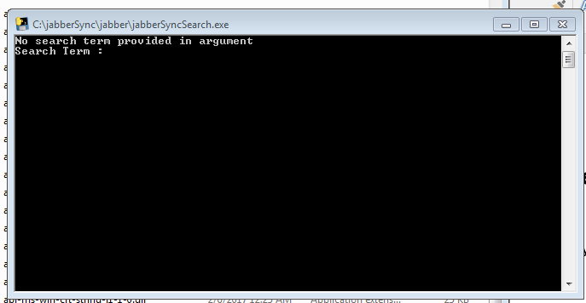

After this you can put in your search term and results should automatically come up in your default web browser.

The application uses present working directory to search for the database hence it has to be started from this location.

Application can also accept search terms via command line argument

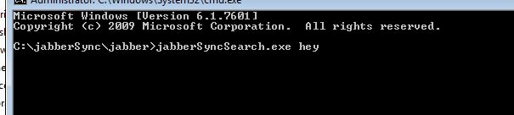

The search results (if any) will be displayed in a web browser

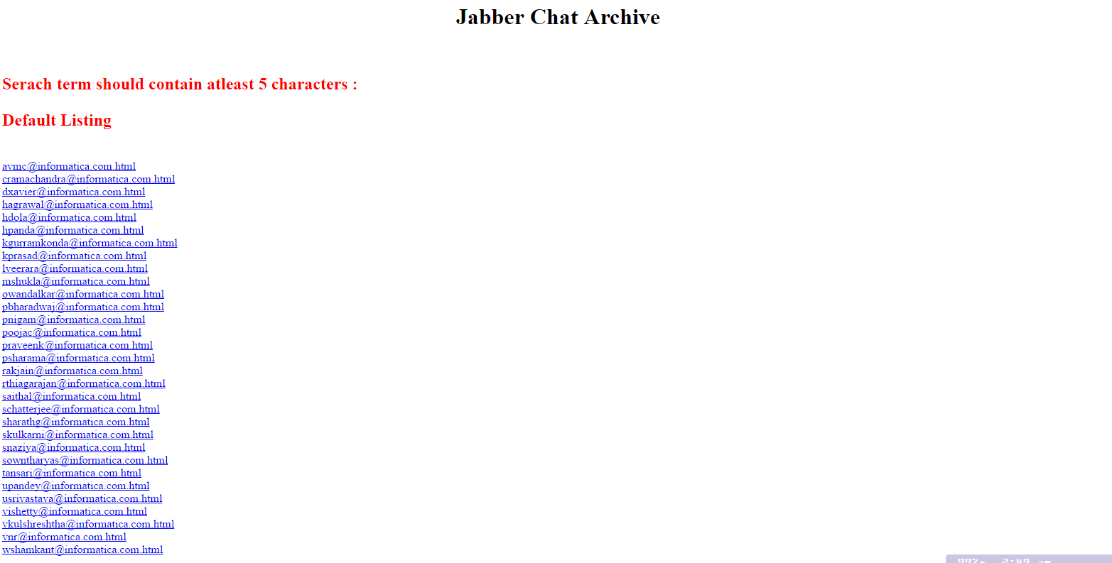

1. Use the search via a shortcut on desktop.
2. Configure slick run to use the application.

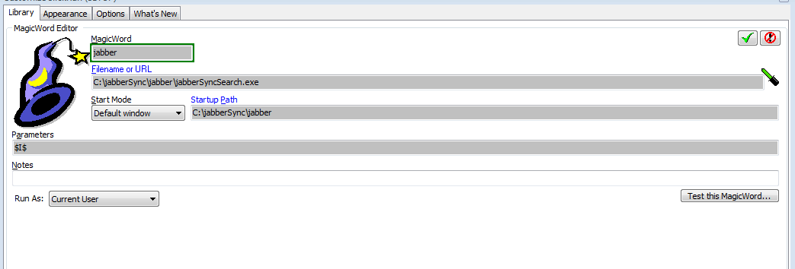

**Flags**

**Jabbersyncsearch.exe -p <search term>** This will keep the search window in command prompt open after bringing up the results page, user can put in another search term